DJ Mixer for Electronic Dance Music

a thesis submitted in partial fulfilment of the requirements for the

degree of B.Sc. (Honours) in Computing with Software Development

Alan Ligman, Date

Table of Contents

Abstract 2

Chapter 1: Introduction 3

Chapter 2: Literature Review 4

2.1 Introduction to DJing 5

2.1.1 What is DJing? 5

2.1.2 What a DJ Actually Does 5

2.1.3 Importance of Track Selection in EDM 6

2.2 Key Components of Music 7

2.2.1 Tempo and beat Matching 7

2.2.2 Keys and Harmonic Mixing 8

2.2.3 Track and cue point selection 9

2.2.4 Mixing techniques for EDM 10

2.3 Technology and AI in DJing 11

2.3.1 Machine Learning applications in Music Analysis 11

2.3.2 AI-based Track Transitions and Mixing Algorithms 12

2.4 Challenges in Automated EDM Mixing 12

2.4.1 Identifying Key Musical Moments in EDM Tracks 12

2.4.2 Ensuring Smooth Transitions Across Different EDM Styles 13

2.4.3 Limitations and Considerations for Automated Mixing 14

RESEARCH INTRO / CHORUS/ OUTROS IN SONGS, how do you define them? 14

Chapter 3: Prototype 14

Chapter 4: Methodology 15

4.1 Overview 15

4.2 Research Question 15

4.3 Chosen Methods 15

4.4 Chosen Method Rationale 15

4.5 Proposed Implementation 15

4.5.1 Dataset Collection 15

4.5.2 Song Features Labelling 15

4.6 Functional Requirements and User Stories 16

User Story 1 17

User Story 2 18

User Story 3 19

User Story 4 20

User Story 5 21

User Story 6 22

4.7 Architectural Diagram 23

4.8 Risk Assessment 24

References 25

# Abstract

# Chapter 1: Introduction

DJing is a difficult art that calls for a thorough knowledge of several musical components, including track selection, tempo, and the best times to switch between tracks to keep the dance floor lively. In pubs, clubs, and social gatherings, DJs deftly manipulate these components to provide cohesive musical experiences. But not every venue has the means to hire professional DJs. The goal of this project is to create an intelligent DJ app that will automate the process of mixing music. The software seeks to provide high-quality music experiences without requiring a human.

Finding the ideal moments to switch between tracks is one of the main DJing challenges. The software will focus on identifying key musical elements, such as choruses, verses, builds, drops, and outros, to fix this. Machine learning models will be created to automate these judgments by identifying music from a carefully selected playlist as training data.

# Chapter 2: Literature Review

## 2.1 Introduction to DJing

### 2.1.1 What is DJing?

“The term 'disc jockey' was first used in 1935 when an American radio commentator named Walter Winchell played music records through the radio while waiting for the details of a high-profile kidnapping. This term depicts any individual who plays pre-recorded music to others. There are many types of DJs equipped with speakers and headphones such as Club DJ, Mobile DJ, Music Producers, and Radio DJs.” (Balleh, Soong, Singh, & Jalil, 2021)

Over the years, DJing has become central to music culture, especially within live performance settings, where DJs are responsible for creating and maintaining the energy of an event. DJs now have a bigger responsibility than just playing pre-recorded music; they must also become experts at smoothly blending songs together to create a unified experience that keeps listeners interested. “The DJ, the primary performer of electronic dance music, is often known to perform by observing the audience’s reaction and livening them by playing suitable EDM songs. DJs mix two EDM songs without any breaks or silences, making the mix structurally coherent and seamless.” (Huang, Fadli, Nugraha, Lin, & Cheng, 2022)

Technological innovations like digital turntables, software, and real-time beat matching tools are essential to modern DJing. These innovations allow artists to experiment with different methods, making DJing an art form that blends technical proficiency with musical intuition, providing audiences with an immersive experience. It has also become more approachable for novices.

### 2.1.2 What a DJ Actually Does

Many people assume that DJing just takes timing and a few fundamental technical abilities, which underestimates the full complexity of the art. Being a great DJ is actually much more than just spinning tunes. A great DJ creates a fully immersive experience by hand-picking songs that fit the space and occasion. DJs are significantly more knowledgeable about music than the typical listener, and they can mix songs together so that the enthusiasm of the audience creates a continuous, one-of-a-kind performance. According to Bill Brewster (2014), “DJs distil musical greatness. They select a series of exceptional recordings and use them to create a unique performance, improvised to precisely suit the time, the place, and the people in front of them. A DJ does is knows music. The DJ knows music better than you, better than your friends, better than everyone on the dancefloor or in the record shop. A great DJ will hit a room with musical moments so new and so fresh that it’s irrelevant that the music is recorded.” (Bill Brewster, 2014)

The true skill of a DJ is not only in mixing tracks together but in their lifelong commitment to finding new music. A tiny portion of the craft consists of the hours spent on stage. The real work comes from years of listening, selecting, and differentiating between songs that are just average and those that can set a memorable mood. “The real work of a DJ is not standing behind some record decks for a couple of hours, looking shifty and waiting for some drink tickets; the time and effort come from a life sifting through music and deciding if it’s good, bad, or ‘oh-my-god-listen-to-this!’ A DJ’s job is to channel the vast ocean of recorded sound into a single unforgettable evening.” (Bill Brewster, 2014)

### 2.1.3 Importance of Track Selection in EDM

The selection of tracks is one of the most basic factors of DJing, yet it always proves to be a crucial success or failure factor, particularly in the EDM genre. It is more complex than just playing hits; the art lies in selecting the right song at the right time to align with the energy and mood of the mix. As Brewster noted, "Part of your job as a DJ is to hear more of the world’s music than your average person, so you can pick the best of that music from your own collection – music that speaks to you personally." (Morse, 2016) This quote emphasizes how crucial it is to choose a unique musical selection that resonates with the DJ's vision as well as the inherent energy of EDM tracks.

In EDM, track selection is not just about personal preference; it requires an understanding of the genre's dynamics. The relentless pursuit of discovering new and innovative tracks is fundamental for an EDM DJ. "To become a good DJ, you have to develop the hunger. You have to search for new records with the insane zeal of a gold rush prospector digging in a blizzard." (Bill Brewster, 2014) This relentless search for unique and experimental sounds provides the very foundation for the art of a DJ and enhances the overall performance on the turntables.

The ability to select tracks remains perhaps the most crucial skill a DJ can possess, particularly in EDM, where versatility and adaptability are key. As Morse articulates, "As a modern DJ, your skills need to be universal and transferable. A mobile DJ might get the chance to play a club gig and have to radically change their music; a bedroom DJ may aspire to play a local festival and need to know how to use the equipment provided instead of their own set-up." (Morse, 2016) This adaptability is highly relevant in today's diverse musical settings, where DJs must feel comfortable transitioning between different EDM subgenres and styles.

## 2.2 Key Components of Music

### 2.2.1 Tempo and beat Matching

In the realm of DJing, particularly within contemporary electronic dance music, tempo and beat matching are critical components that define the success of a performance. Professional DJs are “an under-studied population whose performance involves creating new musical experiences by combining existing musical materials with a high level of temporal precision.” (Nicholas Foster, 2021) This high level of precision is vital, as the tracks used in electronic dance music are often composed with a stable tempo, allowing for further transformation during live performances. “These materials have a stable tempo and are composed with the expectation for further transformation during performance by a DJ for the audience of dancers.” (Nicholas Foster, 2021) The ability to synchronize the tempo and phase of multiple pieces of music is fundamental, as “a fundamental aspect of DJ performance is synchronizing the tempo and phase of multiple pieces of music, so that over seconds or even minutes, they may be layered and transitioned without disrupting the rhythmic pulse.” (Nicholas Foster, 2021) Achieving this synchronization requires not only technical skill but also a deep understanding of rhythm and timing.

Research has highlighted various categories of tempo relevant to music mixing. For instance, categories defined by Karageorghis et al. (2011) include: “slow – 95–100 bpm, medium – 115–120 bpm, fast – 135–140 bpm, and very fast – 155–160 bpm.” (L. Jones a, 2024) This categorization underlines the importance of tempo and beat matching in DJ practice, implying that the training and experience of DJs could develop specific auditory skills.

These insights hold relevance for the development of the project. By understanding the nuanced skills that human DJs develop over time, the AI can be trained to emulate these behaviours, especially in terms of tempo synchronization and beat matching. Integrating machine learning algorithms that analyse existing musical materials structure will enable the AI to recognize patterns and execute seamless transitions between tracks, akin to a human DJ's approach.

### 2.2.2 Keys and Harmonic Mixing

Harmonic mixing is a crucial aspect of DJing that significantly impacts the overall sound of a set. Mixing tracks out of key can “sound displeasing and turn a happy, vibrant audience into an unsettled one in a short period of time.” (Austen Smart, 2020) This highlights the importance of understanding music theory when blending different tracks. The foundation of harmonic mixing lies in the concept of musical keys. While there are up to 88 keys on a piano, there are only 12 different notes that can be combined to create various keys. For example, “the key of C major contains these notes: C D E F G A B,” whereas “the key of B minor contains these notes: B C D E F G A.” (Austen Smart, 2020) This knowledge allows DJs to select tracks that will complement each other harmonically, enhancing the listening experience.

The concept of chords within each key further adds depth to this process. The most commonly used chords are based on the first, fourth, and fifth notes of the key. For instance, in the key of C major, the common chords are C major (C E G), F major (F A C), and G major (G B D). Understanding how these chords work together is essential for creating seamless transitions between tracks. “the more notes two keys have in common, the better they will sound.” (Austen Smart, 2020) Mixing a track in C major with a track in B minor, for instance, may lead to a less harmonious blend because they share only two notes. This awareness of key relationships is particularly vital when executing techniques like bass swaps, where tracks are played together for several phrases.

“To facilitate harmonic blending, DJs often refer to tools like the Circle of Fifths” (Austen Smart, 2020), which illustrates the relationships between different keys. According to the text, “the key that is the fifth note of another key is always complementary,” (Austen Smart, 2020) indicating that keys closely aligned in the Circle of Fifths will likely sound better together. For example, the Circle of Fifths shows that G major (G A B C D E F#) shares all but one note with C major, making them compatible for mixing.

### 2.2.3 Track and cue point selection

In the initial stage of the automatic DJ system, "Songs are annotated offline using the beat tracker, downbeat tracker and structural segmentation modules." This ensures that the system has the necessary metadata to facilitate mixing later. During the performance, "The mix generation and playback happen 'live' by iteratively performing track and cue point selection, time-stretching, beatmatching, and crossfading..." This dynamic approach allows for a seamless listening experience. A critical aspect of the mixing process is how transitions are handled. "The transition type defines which segments ('low' or 'high') of the first song and the new song are overlapped..." This plays a vital role in maintaining musical cohesion. After determining ideal transition points, "Once the cue points are known, the crossfade is established." This is essential for creating a polished final product.

To ensure musical harmony, "Only songs that are in key with the current song are considered." This initial filtering step is crucial for maintaining the overall flow of the mix. To further refine the mix quality, "Vocal activity is detected such that overlapping vocals of both songs is avoided." This avoids dissonance and enhances the listening experience. Ultimately, the selection process culminates in a precise choice: "...the song with the highest rhythmic similarity to the current song and without vocal clashes is selected as the next song." This careful consideration ensures that transitions are both smooth and enjoyable.

Cite

### 2.2.4 Mixing techniques for EDM

In Electronic Dance Music (EDM) mixing, several techniques are employed by DJs to ensure seamless transitions between tracks, thereby maintaining a continuous musical flow. One of the most fundamental techniques is beatmatching, where the DJ adjusts the tempos of two tracks to align their beats-per-minute (BPM). This synchronization allows for smooth transitions between tracks without disrupting the rhythm, a crucial aspect of genres like house and techno, where a steady, uninterrupted beat is essential to the experience.

In addition to beatmatching, cueing plays a pivotal role in managing transitions. DJs set precise cue points within tracks, which act as reference markers for where the next track will be introduced. "Cue points are timestamps in a track that indicate where to start and end the track in a mix" (Taejun Kim, 2020). This process enables DJs to control the timing of transitions, ensuring they occur at appropriate musical moments, thus enhancing the coherence of the set.

Another important technique is the use of EQ adjustments, particularly during transitions between tracks. By manipulating the bass, midrange, and treble frequencies, DJs can prevent frequency clashes, especially in the bass range, where overlapping low frequencies can result in muddled sound. As noted, "DJs often tweak the bass, mid, and treble frequencies of the tracks to ensure that overlapping elements... don't clash during a transition" (Taejun Kim, 2020). This approach ensures that the mix remains clear and sonically balanced.

Moreover, harmonic mixing is employed to match the musical keys of consecutive tracks. This technique prevents dissonance and ensures that transitions are musically pleasing. DJs often use key-locking tools or make slight adjustments to the pitch of a track to maintain harmonic compatibility. The study observes that DJs "tend not to change the tempo and/or key of tracks much to avoid distorting the original essence of the tracks" (Taejun Kim, 2020), which highlights the importance of preserving the musical integrity of the original recordings during the mixing process.

## 2.3 Technology and AI in DJing

### 2.3.1 Machine Learning applications in Music Analysis

Artificial intelligence (AI) has significantly impacted the field of music DJing, transforming how DJs curate, mix, and interact with their audience. AI-driven music DJ systems employ machine learning algorithms to analyse musical features, recommend tracks, and automate mixing processes, thereby enhancing the overall user experience and creativity in live performances.

One of the primary applications of AI in music DJing is the automation of track selection and mixing. “AI systems can analyse vast music libraries to suggest tracks that fit specific styles or moods,” highlighting the efficiency of AI in creating seamless playlists (Pachet, 2016) These systems employ algorithms that consider various musical attributes, such as tempo, key, and energy level, to ensure harmonic mixing and smooth transitions between tracks. For instance, AI-driven platforms can analyse the beats per minute (BPM) of a track and select songs that complement each other, allowing for more cohesive sets.

AI can enhance the creative aspects of DJing through music generation and remixing capabilities. “These models can learn from a DJ's style and generate new content that reflects their artistic vision,” allowing DJs to produce original mixes or remixes that maintain their unique sound while incorporating innovative elements (Briot, 2018). By leveraging AI, DJs can experiment with various styles and genres, pushing the boundaries of traditional DJing.

### 2.3.2 AI-based Track Transitions and Mixing Algorithms

Another significant advancement in AI-driven DJing is the development of harmonic mixing algorithms, which facilitate seamless transitions by ensuring that consecutive tracks are harmonically compatible. This technique utilizes machine learning algorithms to analyze the musical keys of tracks, allowing DJs to avoid dissonance during transitions. As stated, “AI systems can analyze vast music libraries to suggest tracks that fit specific styles or moods,” which enhances the DJ’s ability to make harmonious sets (Pachet, 2016). This automation not only helps the mixing process but also improves the overall listening experience by maintaining musical coherence.

Automated mixing and transition generation have emerged as powerful tools for DJs. AI-driven systems can learn a DJ's style and generate transitions that reflect their unique artistic expression. It has been noted that “RNNs can learn from a DJ's style and generate new content that reflects their artistic vision,” offering DJs innovative ways to enhance their performances (Briot, 2018). By leveraging these generative models, DJs can produce original mixes that capture their essence while incorporating fresh elements.

## 2.4 Challenges in Automated EDM Mixing

As AI technology continues to evolve, its application in music, particularly electronic dance music (EDM), is growing. While AI DJ systems offer powerful tools for automating mixing and track selection, they also present unique challenges. These challenges often stem from the complexity of EDM tracks, the diversity of sub-genres, and the nuanced aspects of live performance. This section explores key challenges AI systems face when automating EDM mixing, from identifying critical musical moments to maintaining energy flow.

### 2.4.1 Identifying Key Musical Moments in EDM Tracks

One of the most significant challenges in automating EDM mixing is identifying key musical moments within tracks. Human DJs, through years of experience, instinctively recognize build-ups, drops, and breakdowns, making these transitions seamless. However, for AI-driven systems, identifying such moments is far more complex, requiring sophisticated algorithms capable of analysing the structure of the music in real time.

### 2.4.2 Ensuring Smooth Transitions Across Different EDM Styles

Transitioning between different Electronic Dance Music (EDM) styles presents a significant challenge for automated Ai DJ. This complexity comes from diverse characteristics and structural elements inherent to various EDM genres. “One of the primary obstacles is tempo, as EDM subgenres can vary widely in beats per minute (BPM), from the slower pace of deep house to the frenetic rhythms of drum and bass.” (Johnson, 2022) found that Ai systems must not only detect these tempo differences but also execute gradual tempo changes or abrupt shift while maintaining rhythmic coherence. This process known as beat matching is fundamental to smooth transitions but requires advanced algorithms to replicate decisions made by human DJs.

Harmonic compatibility is crucial for seamless transitions; tracks sharing the same Camelot number (e.g., 8A and 8B) are harmonically compatible, allowing for smooth mixing. Moving one step clockwise or counterclockwise on the wheel results in a change of only one note, facilitating easy transitions between tracks.

Implementing the Camelot Wheel in AI algorithms may pose challenges, such as real-time key detection and understanding key relationship. The AI system will need to accurately identify a track’s key while considering the overall musical context and energy levels. Additionally, the algorithm will need to balance adherence to harmonic rules with creative decision-making like human DJs (Smith, 2023)

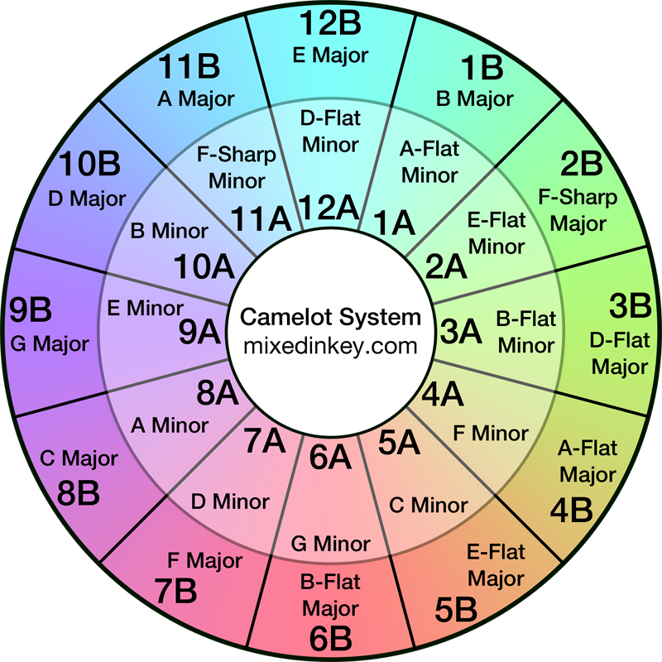

##### *Figure 1 – Camelot Wheel*

### 2.4.3 Limitations and Considerations for Automated Mixing

# RESEARCH INTRO / CHORUS/ OUTROS IN SONGS, how do you define them?

# Chapter 3: Prototype

# Chapter 4: Methodology

## 4.1 Overview

This thesis explores the use of Artificial Intelligence and Machine learning to create a mixing DJ for electronic dance music (EDM). The primary objective is to explore whether AI and Machine Learning can effectively assist or even replace traditional DJs in creating seamless and engaging music mixes. Through this research, I aim to evaluate the potential of these technologies to enhance the mixing process and improve creativity.

## 4.2 Research Question

Can AI-based DJ systems mimic the decision-making process of professional DJs in terms of track selection and musical transitions?

## 4.3 Chosen Methods

Youtube playlist downloader will be used for the collection of EDM songs. This process begins with carefully selecting EDM songs with various artists and within close to each other BPM (Beats Per Minute). These songs will be then put through my own built algorithms to detect various song characteristics.

PyTorch will be employed to train the AI model to recognize different music characteristics and create accurate mixes. PyTorch is chosen for its ease of use, flexibility, and rapid prototyping capabilities.

## 4.4 Chosen Method Rationale

The YouTube playlist downloader is selected for its ability to easily download and convert YouTube videos to MP3 files. Custom-built algorithms are chosen to provide tailored feature extraction specific to the project's needs. PyTorch is selected for its user-friendly interface and rapid prototyping capabilities.

## 4.5 Proposed Implementation

The dataset will be collected by downloading and preprocessing the MP3 files. Custom-built algorithms will be used to extract features, which will then be labelled for training the AI model with PyTorch. The model will then be trained to analyse music features and create seamless mixes.

### 4.5.1 Dataset Collection

Utilize a YouTube playlist downloader to gather EDM songs from various artists. This involves selecting relevant YouTube playlists or channels that feature EDM music and downloading the audio files in MP3 format.

### 4.5.2 Song Features Labelling

Develop custom algorithms to analyse the downloaded or collected audio files and extract various song characteristics. These features include BPM, key signatures, tempo, structural elements like verse, chorus, and bridge, and other relevant audio features. After label the extracted features accurately to create a comprehensive dataset. Ensure the dataset is diverse and well-labelled to improve the performance of the AI model.

### 4.5.3 Model Training

Use PyTorch to build and train the AI model. This involves loading the labeled dataset, defining the model architecture, and training the model to recognize different music characteristics.

### 4.6 Functional Requirements and User Stories

|  |  |  |  |  |  |
| --- | --- | --- | --- | --- | --- |
| Task ID | Requirement | Must Have | Should Have | Could Have | Won’t Have |
| FYP-1 | Playlist Import | ✔ |  |  |  |
| FYP-2 | Audio Analysis for Mixing | ✔ |  |  |  |
| FYP-3 | Automatic Mixing of Tracks | ✔ |  |  |  |
| FYP-4 | User Interface for Playlist Management |  | ✔ |  |  |
| FYP-5 | User Feedback System |  |  | ✔ |  |
| FYP-6 | Performance Optimization |  |  |  | ✔ |

### User Story 1

**Unique Number:** US 001

**Title:** Playlist Import

**Dependency:** None

**Estimate:** 8 hours

**Priority:** Must Have

**Description:** As a music enthusiast, I want to import a playlist from a folder of MP3 songs so that I can create a seamless mix for playback.

**Acceptance Criteria (Done Criteria)  
Success:**

1. User can browse and select a folder containing MP3 files.
2. The "Import Playlist" button successfully triggers the file selection process.
3. The system accurately imports all selected MP3 files and prepares them for playback.

**Failure:**

1. User receives an error message if no MP3 files are found in the selected folder.
2. The import process fails if the folder contains unsupported file formats.
3. User interface is not intuitive, making it difficult to select the desired folder.

### User Story 2

**Unique Number:** US 002  
**Title:** Audio Analysis for Mixing  
**Dependency:** US 001  
**Estimate:** 8 hours  
**Priority:** Must Have  
**Description:** As a music producer, I want to develop an AI that performs audio analysis of music so that I can understand key musical characteristics for mixing.

**Acceptance Criteria (Done Criteria)**  
**Success:**

1. AI successfully analyzes audio files for BPM, key signatures, tempo, and structural elements.
2. A diverse dataset is compiled and used effectively for training the AI model.
3. Feature extraction techniques are implemented for BPM, key, tempo, and structure.

**Failure:**

1. AI fails to analyze or provides inaccurate results for given audio files.
2. Dataset lacks diversity or is poorly labeled, impacting AI performance.
3. Implemented techniques do not yield expected feature extraction results.

### User Story 3

**Unique Number:** US 003  
**Title:** Automatic Mixing of Tracks  
**Dependency:** US 002  
**Estimate:** 10 hours  
**Priority:** Must Have  
**Description:** As a user, I want the app to automatically mix tracks after a playlist is inputted so that I can enjoy a seamless listening experience.

**Acceptance Criteria (Done Criteria)**  
**Success:**

1. The AI model accurately analyses music features such as BPM, key signature, and tempo.
2. Automatic labeling of parts of songs occurs correctly with proper identification of segments (verse, chorus, bridge).

**Failure:**

1. The mixing process results in audible errors or mismatched transitions.
2. The AI model fails to identify musical segments correctly.
3. The application crashes or experiences slow performance when processing tracks.

### User Story 4

**Unique Number:** US 004  
**Title:** User Interface for Playlist Management  
**Dependency:** US 001, US 003  
**Estimate:** 8 hours  
**Priority:** Should Have  
**Description:** As a user, I want to manage my playlists and view finished remixes effectively so that I can enjoy and organize my music.

**Acceptance Criteria (Done Criteria)**  
**Success:**

1. The main dashboard displays user playlists with titles and cover images.
2. A dedicated section for finished remixes is available, including titles and a play button for previews.
3. Users can create, rename, delete, and organize playlists easily.

**Failure:**

1. The UI does not load correctly or displays broken links.
2. Users are unable to perform actions like renaming or deleting playlists.
3. Feedback mechanisms for user interactions are non-functional.

### User Story 5

**Unique Number:** US 005  
**Title:** User Feedback System  
**Dependency:** n/a  
**Estimate:** 8 hours  
**Priority:** Could Have  
**Description:** As a user, I want a simple and user-friendly form to provide feedback so that I can share my thoughts and help improve the application.

**Acceptance Criteria (Done Criteria)**  
**Success:**

1. The feedback form is easy to navigate and submit.
2. Required fields are validated correctly before submission.
3. User feedback is collected and stored for analysis.

**Failure:**

1. The form submission fails without clear error messages.
2. Feedback does not get recorded in the system.
3. Users find the form confusing or difficult to use.

### User Story 6

**Unique Number:** US 006  
**Title:** Performance Optimization  
**Dependency:** n/a  
**Estimate:** 8 hours  
**Priority:** Won’t Have  
**Description:** As a developer, I want to optimize the application’s performance to ensure smooth playback during mixing and reduce load times.

**Acceptance Criteria (Done Criteria)**  
**Success:**

1. Code review identifies and refactors inefficient code segments.
2. Resource management techniques are implemented successfully, improving performance.
3. Application load times are significantly reduced.

**Failure:**

1. Refactored code introduces new bugs or performance issues.
2. Resource management techniques do not yield the expected performance improvements.
3. Users report continued performance issues after optimization.

### 4.7 Architectural Diagram

TO BE DONE

### 4.8 Risk Assessment

|  |  |  |  |  |
| --- | --- | --- | --- | --- |
| Risk | Impact  (High,Med,Low | Likelihood (High,Med,Low) | Preventing Activity | Plan of Action |
| Insufficient training data for machine learning models | The model may not perform well in identifying musical elements - High | Medium | Utilize techniques to artificially expand the trained dataset by creating variations of existing data. | Actively seek out open datasets related to music. |
| Developing accurate beat-matching algorithms | Core functionality might fail - High | Medium | Regularly test and validate the algorithm. | Engage a real-life DJ or music producer to test the beat and music matching functionality. |
| Difficulty in defining optimal transition points between tracks | he mixes might sound unnatural - Medium | Medium | Implement various music transition techniques to create smoother transitions between tracks | Study and research effective transitions methods used by experienced DJs |

# Chapter 5: Prototype

## 5.1 Downloading a music dataset

I have found a YouTube playlist downloader on GitHub which i have utilized in my project to download a playlist of Drum and Bass songs.

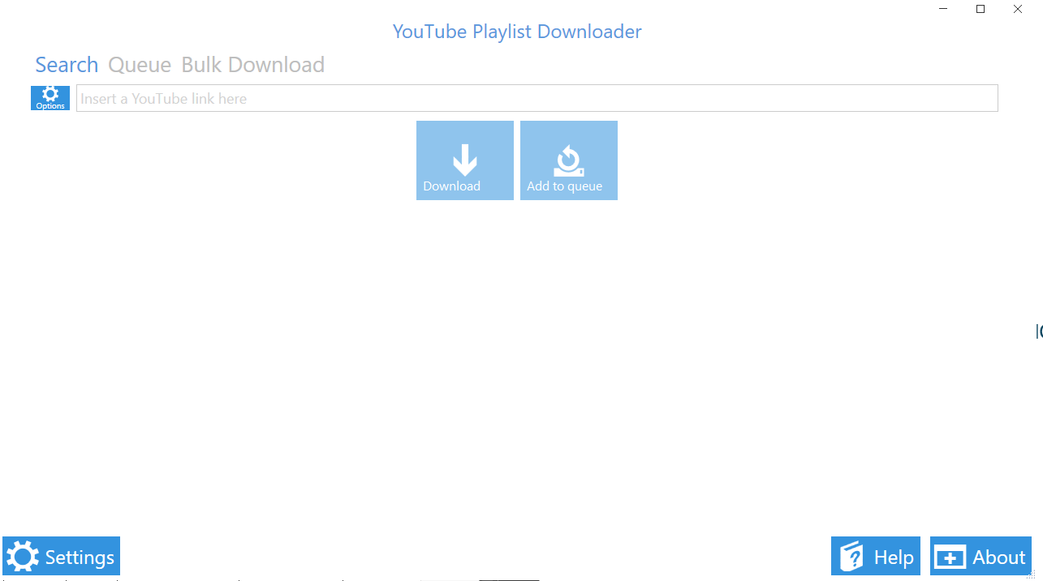

## 5.2 Playlist import implementation

I have started implementing the project by choosing an environment to code in, I decided to go with PyCharm, I picked PyCharm because it is an excellent choice for Python Projects due to its features like, intelligent code assistance, debugger, built-in terminal and version control. I have created a new project and started coding.

### 5.2.1 Music Upload & Playback

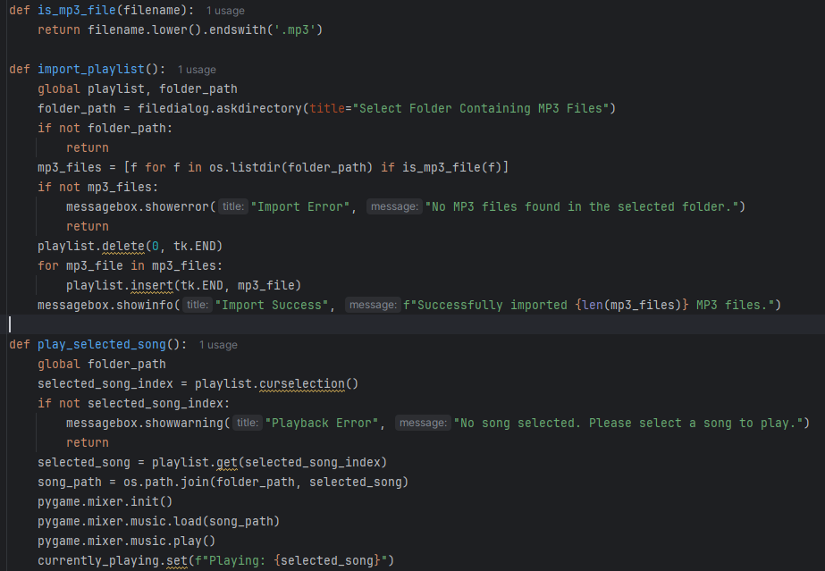

5.2.2 GUI

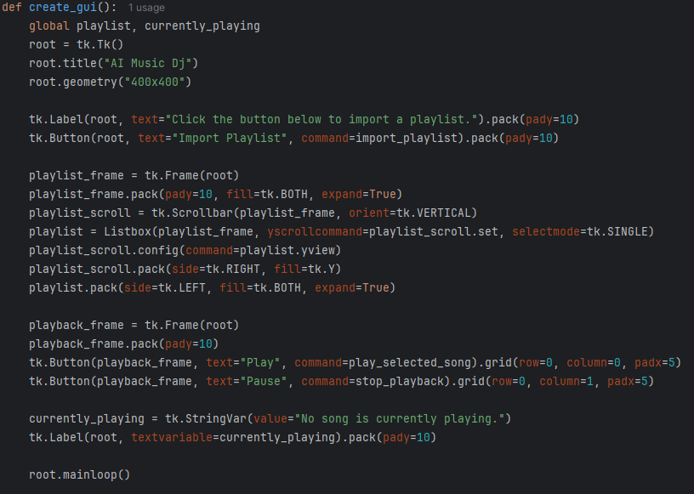

# References

Austen Smart, S. S. (2020). *FutureDJs: How to DJ.* Faber Music.

Bertin-Mahieux, T. E. (2015). The million song dataset. *Proceedings of the 12th International Society for Music Information Retrieval Conference (ISMIR).*

Briot, J. P. (2018). *ACM Computing Surveys.* Retrieved from ACM Computing Surveys: https://arxiv.org/abs/1709.01620

Johnson, A. e. (2022). Tempo Detection and Manipulation in Ai-Driven EDM Mixing. *Journal of Music Technology*, 267-280.

L. Jones a, C. K. (2024). The exercise intensity–music-tempo preference relationship: A decennial revisit. *Psychology of Sport & Exercise*, 1-2.

Nicholas Foster, L. B. (2021). Accuracy of Tempo Judgments in Disk Jockeys Compared to Musicians and Untrained Individuals. *Frontiers in Psychologyt*.

Pachet, F. &. (2016). Recommendation Systems for Music. *Proceedings of the IEEE* (pp. 309-321). IEEE.

Smith, B. L. (2023). Harmonic Analysis for Automated EDM Transitions. *Proceedings of the International Conference on AI in Music*, (pp. 112-125).

Taejun Kim, M. C.-H. (2020). COMPUTATIONAL ANALYSIS OF REAL-WORLD DJ MIXES USINGMIX-TO-TRACK SUBSEQUENCE ALIGNMENT. *COMPUTATIONAL ANALYSIS OF REAL-WORLD DJ MIXES USINGMIX-TO-TRACK SUBSEQUENCE ALIGNMENT*, 5-8.

Balleh, A. S., Soong, H.-C., Singh, S. K., & Jalil, N. A. (2021). Automated DJ Pad Audio Mashups Playback Compositions in Computer Music Utilizing Harmony Search Algorithm. *Automated DJ Pad Audio Mashups Playback Compositions in Computer Music Utilizing Harmony Search Algorithm* (pp. 4-5). Kota Kinabalu, Malaysia: IEEE.

Bill Brewster, F. B. (2014). *Last Night a DJ Saved My Life.* London.

Huang, H.-W., Fadli, M., Nugraha, A. K., Lin, C.-W., & Cheng, R.-G. (2022). AI DJ System for Electronic Dance Music. *AI DJ System for Electronic Dance Music*, 1-2.

Morse, P. (2016). *Rock the Dance Floor! .*

MIXING IN KEY: How to use HARMONIC MIXING to PERFECT your DJ Mixed -https://www.youtube.com/watch?v=U_tS7iMwU54&ab_channel=Crossfader